Storage type

* Flash Memory -> Internal.

* SD card.

* Network boot.

Website (refer):developer.ruggedboard.com

files (they design it)(software=design)
||

archiecture -> core -> SOC -> SOM -> SBC
||

Physical components (Hardware)

___pxerting___
The way to boot & mount root files => E-pading.

source <- file -> executable

at91bootstrap code

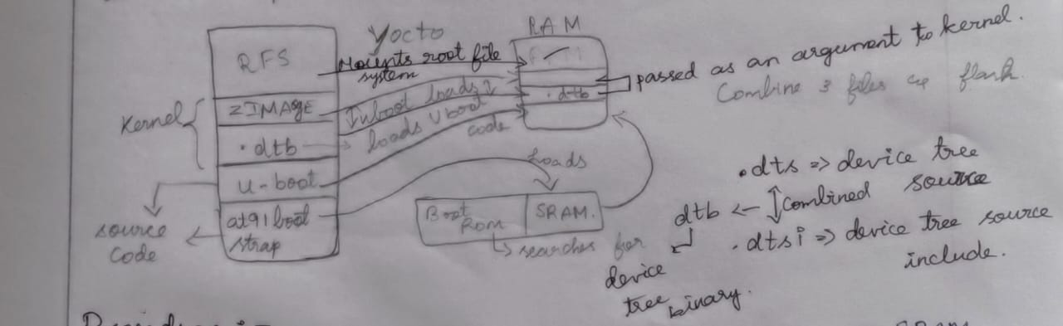

Inside Soc the code is uploaded.

The code didn't give to anyone.

Boot ROM work it load at91bootstramp into S.RAM

Soc = They Can Create any type.

.dts = Data Tree Source.

.dtsI= Data Tree Source Include.

Suma leave it my thoughts (source file to binary)

.dtb = data tree binary

Procedure:-

SOC -> has a board & flashed -> Boot ROM (source code)=[they didn’t give(kudukamatan)] -> searches at91 boot strap -> SRAM (Loads at91 boot strap code) -> goes to RAM as initializes -> loads the boat code to RAM -> U boot loads the .dtb file up z image to RAM.

.dtb

*can be attached to any kernel.

* makes work easier by reducing confussion in connecting the board & the
kerned based on its type.

* passed as an argument to kernel.

why it mounts the RFS.

It mount RFS = flash into RAM.

